MSc Digital and Technology Solutions



SUBJECT: DIGITAL TRANSFORMATION LEADERSHIP

SUBJECT CODE: CETM68

Project Title: An Approach to Serverless ChatOps Automation within a Live Project and the impact this has on Functional Teams

Name: Alan John Heslop (bh83dl)

Student ID No: 199302280

Lecturer: Gavin McClary

Date: Monday, 24 January 2022

**Update:**

<https://docs.aws.amazon.com/lex/latest/dg/slack-bot-association.html>

Potentially, I can use amazon lex

**Resources to review:**

<https://victorops.com/blog/top-chatops-use-cases>

google search AWS CHATOPS USE CASES

https://www.plutora.com/ci-cd-tools/communication-chatops-tools

provision a ci/cd pipeline.

How well does the culture of ChatOps implement change and continuous improvement, and can tailor fit the ChatOps to improve our current project?

Look at SQS INSTEAD OF SNS

**Overview**

**Abstract do this at the end**

|  |  |
| --- | --- |
|  | *Define the aims and objects of the project* |

* **Research problem**
  + Practical or theorhetical problem does the research respond to
  + Problem
    - Investivate, test, analyse, evaluate
    - Present or past not future.
* **Methods**
  + Indicate the research methods you’ve used to answer the research question
  + What you did
  + 1 or 2 sentance
  + Past tense
* **Key results or arguments**
  + Summarise the main research results
  + Past or present tense
* **Conclusion**
  + What is your answer to the problem or question
  + Clear understanding that the research has proved or continued

What is the in-discipline challenge and research question of your project?  
Why are you doing this project e.g. the justification, relevance and importance?  
What is the practical element and expected outcome?  
What are the main results / findings you expect to get from your practical work and how this will help you answer your   
research question

**Aim & Objectives**

|  |  |
| --- | --- |
|  | *Define the aims and objects of the project* |

What is the main aim of your project?

**Aims**

The aim of this project is to provide an implemented version-controlled chatbot and architecture utilising the AWS cloud-based services, serverless concepts, and instant messaging service for the chatbot to be implemented. Also, to provide an overview of the culture in ChatOps and the impact on functional teams.

**The objectives to achieve this aim are:**

* Integrate a working version of a chatbot utilising AWS services such as AWS Lambda, AWS SNS. Amazon Lex, AWS Chatbot, and AWS CloudWatch.
* Design an architecture for each individual component lifecycle of the chatbot, including the serverless aspects using AWS Cloud.
* Ensure that security aspects are covered.
* Notifications and Monitoring

**Timetable**

|  |  |
| --- | --- |
|  | *Provide detailed information on the expected timetable for the project. Break the project into phases, and provide a schedule for each phase.* |

|  |  |  |
| --- | --- | --- |
|  | Description of Work | Start and End Dates |
| **Phase One** | Project Proposal Hand-in | 28thJanuary-11th February 2022 |
| **Phase Two** | Allocated Supervisor | 14th February 2022 |
| **Phase Three** | Project Planning & Refinement | 11th-25th February |
| **Phase Four** | Research and practical work, early drafts of research poster; evidence collation | 4th February– 15th July |
| **Phase Three** | Research Poster and Viva | 29th July 2022 |
| **Phase Four** | Practical Demonstration | 5th August 2022 |

**Budget**

|  |  |
| --- | --- |
|  | *State the proposed costs and budget of the project. Also include information on how you intend to manage the budget.* |

|  |  |  |
| --- | --- | --- |
|  | **Description of Work** | **Start and End Dates** |
| **Phase’s** | All work should be carried out using AWS Free Tier – small charges may occur, but primarily it will be tried to kept to £0.00 | Whole project |
|  | **Total** | **£ 0.00** |

**Key Personnel**

|  |  |
| --- | --- |
|  | *List the key personnel who will be responsible for the completion of the project, as well as other personnel involved in the project.* |

|  |  |
| --- | --- |
| **Client** | Angus Greenland (DXC) |
| **Sponsor** | Gavin McClary (University) |
| **Project manager** | Alan Heslop |
| **Team** | Alan Heslop |

**Research**

|  |  |
| --- | --- |
|  | *This section focuses on what is it you are going to research – what is it you want to find out…* |

What is your research question?

The research question: *How well do the integration and use of ChatOps implement change, continuous improvement, and culture? Also, can ChatOps be tailor-fitted to improve projects?*

The research areas of interest include:

* Effectiveness of different types of chatbot services
  + Aws chatbot
  + Amazon lex
  + Slackbot
  + YellowAnt
  + HuBot
* What is your purpose in reviewing literature - what are you expecting to find out and apply practically from your research?

The goal(s) of reviewing the literature in the ChatOps spectrum is to identify the effectiveness of implementing a chatbot within a team, using cloud services to monitor, notify, and other related tasks. Analysing how previous projects have been completed to see how the serverless chatbot copes with a centralised platform (e.g., Slack/Teams) and the integration with project methodologies (e.g., JIRA/Monday).

Understanding this environment and implementing a PoC chatbot will present the advantages and disadvantages of chatbots. This will also provide an insight into the impact ChatOps has on teams (e.g., collaboration, code review, building high performing teams) and how it differs from DevOps.

What are you hoping to find out through creating the practical element? How does it relate to your research question and focus?

Practical application from the research is expected to identify the best choice of ChatBot for a selected project by pulling and pushing data to services for transparency.

The practical element will enable oversight of tried and tested methods to create a fully collaborative chatbot, to be adapted to any project using a Natural Language Processing/Understanding (NLP/NLU).

This project will be handled using a range of methodologies (e.g., Agile, Scrum, Kanban) to provide an outcome of a chosen methodology.

**Practical Element**

|  |  |
| --- | --- |
|  | *What is the main practical element you intend to create – how will you do that…* |

What is the practical element going to be and what is it going to involve, do and be used for?

The practical element of the project will involve planning, designing, implementing, reviewing, and testing a PoC implemented into a chosen instance messaging service to provide the user with a collaborative application.

How are you going to design and develop it

The intended PoC will be developed using up-to-date concurrent technology provided by Amazon AWS Web Services, however, Azure will be reviewed as another provider of cloud computing.

* AWS Microservices
  + AWS Simple Notification Service
* Slack integration
* Slash commands toolsets
* Bring in richer data
* Markdown tables/formatting
* File attachments for logging

Planning the project using a JIRA board and adapting a sprint approach will be useful to keep track of the application lifecycle. Discussions with team members who are able to test at each sprint and receive their feedback will help provide a different outcome using their opinion. Due to the nature of this project, a hybrid management style will be taken into account to provide a positive nature through each sprint.

What methods/approaches are you going to use?

Methods such as an Agile approach, with fortnightly sprints and story development, will be applied using JIRA and other agile tools and technologies, alongside meetings and discussions with current FPPS staff as well as DXC Software Engineers responsible for the development and maintenance of the legacy Databases. Due to the nature of the project, a hybrid management style will be utilised, with some elements of Agile alongside Waterfall methodologies.

What will the final outcome be – what do you hope to provide the client/sponsor?

The final outcome

The practical outcome of the project will be to provide the client with a workable PoC that can be integrated into an instant messaging service (Slack) to provide further transparency on projects.

What is the client/sponsor going to do with your practical element?

The client can then use this as a demo to implement in other teams to provide similar results (e.g., collaboration and high-performing teams)

How will you evaluate the success of your outcome?

In order to evaluate the success of the practical outcome, the client must be able to see a working example of pulling and pushing data, as this leads to improved collaboration within teams. For example, the client would be able to identify if an engineer was able to pull logs, JIRA tickets, and documentation. Also, an engineer will be able to push (update) data through the user interface of the instant messaging platform.

**Learning and Development**

|  |  |
| --- | --- |
|  | *Identify how this project relates to your MSc program, outlining the skills and knowledge required for the project and how the project will enable you to extend and improve these.* |

What areas of knowledge / practical skills will you be demonstrating in your research and in creating the practical element?

This project will encompass the MSc program in its entirety with technical and project management knowledge. Such technology skills required in order to satisfy the end result are cloud computing, AWS microservices, cloud security, communication methods, and continuous integration.

* Cloud computing
* Communication methods
* CI/CD pipeline
* AWS Architecture
* Team/Channel hierarchy/architecture

And what areas do the project enable you to further develop?

Overall the project in itself enables further development as this is an unfamiliar area. Improvement will primarily come from Cloud Technology (AWS), Methodologies (Agile), and implementing Software as a Service using GitHub (SaaS) for version control.

**Research Ethics**

|  |  |
| --- | --- |
|  | *Does your research involve people, e.g. interviews, focus groups, design workshops, policy discussions, user studies, evaluation, etc.?* |

Due to the nature of chatbots, transparency within the workplace is a basis of good work ethics and best practices of cooperation.

References

*Include a list of citations*

* 1. Letter/Email of support from Client / Sponsor

*Guidance: short letter from your sponsor client. It can be as simple as:*

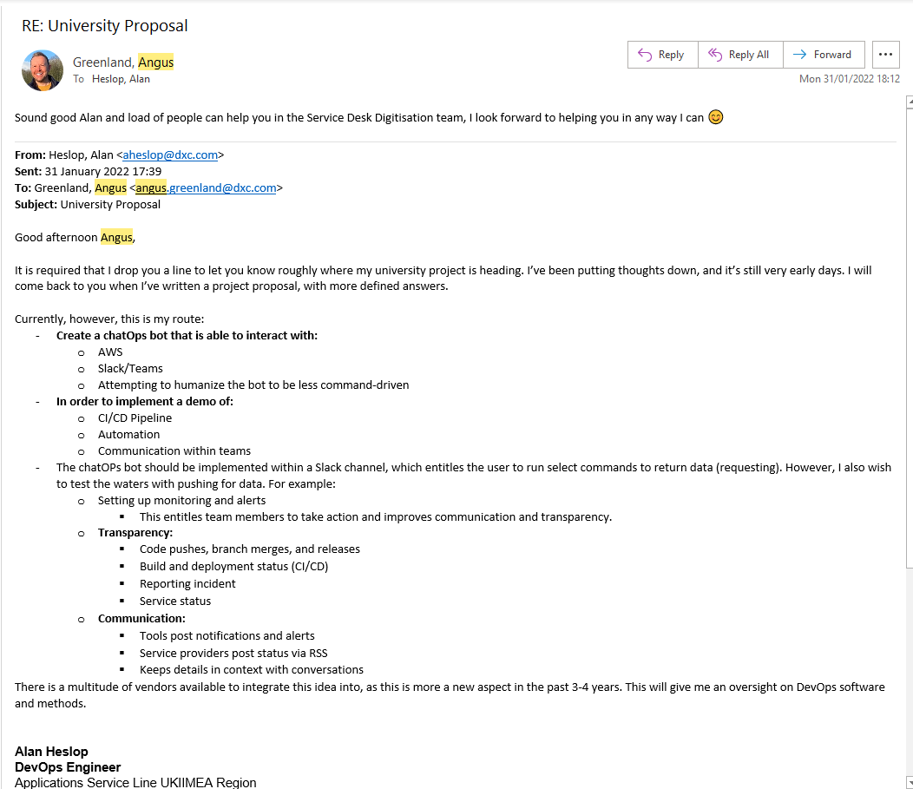

Sponsor / Client Name Signature

Date

* 1. Client-Sponsor MSc Project Proposal Template

*Guidance: Include the completed template*

* 1. Supervisor (if applicable)

*Guidance: short email of support from supervisor*

**Approval and Authority to Proceed**

|  |  |  |  |  |
| --- | --- | --- | --- | --- |
|  |  |  |  |  |
| Angus Greenland  (Project Client)  Date: _____________ |  | Gavin McClary  (Project Sponsor)  Date: _____________ |  | Alan Heslop  (Project Manager)  Date: _____________ |